

Additional Assessment Materials

Summer 2021

Pearson Edexcel GCE in Mathematics

9MA0 (Public release version)

Resource Set 1: Topic 5

Trigonometry

# **Pearson: helping people progress, everywhere**

Pearson aspires to be the world’s leading learning company. Our aim is to help everyone progress in their lives through education. We believe in every kind of learning, for all kinds of people, wherever they are in the world. We’ve been involved in education for over 150 years, and by working across 70 countries, in 100 languages, we have built an international reputation for our commitment to high standards and raising achievement through innovation in education. Find out more about how we can help you and your students at: [www.pearson.com/uk](http://www.pearson.com/uk)

Additional Assessment Materials, Summer 2021

All the material in this publication is copyright

© Pearson Education Ltd 2021

**General guidance to Additional Assessment Materials for use in 2021**

**Context**

* Additional Assessment Materials are being produced for GCSE, AS and A levels (with the exception of Art and Design).
* The Additional Assessment Materials presented in this booklet are an optional part of the range of evidence teachers may use when deciding on a candidate’s grade.
* 2021 Additional Assessment Materials have been drawn from previous examination materials, namely past papers.
* Additional Assessment Materials have come from past papers both published (those materials available publicly) and unpublished (those currently under padlock to our centres) presented in a different format to allow teachers to adapt them for use with candidate.

**Purpose**

* The purpose of this resource to provide qualification-specific sets/groups of questions covering the knowledge, skills and understanding relevant to this Pearson qualification.
* This document should be used in conjunction with the mapping guidance which will map content and/or skills covered within each set of questions.
* These materials are only intended to support the summer 2021 series.

**1.**



**Figure 1**

The shape *ABCDOA*, as shown in Figure 1, consists of a sector *COD* of a circle centre *O* joined to a sector *AOB* of a different circle, also centre *O*.

Given that arc length *CD* = 3 cm, ∠*COD* = 0.4 radians and *AOD* is a straight line of length 12 cm, find

(*a*) the length of *OD*,

**(2)**

(*b*) the area of the shaded sector *AOB*.

**(3)**

**(Total for Question 1 is 5 marks)**

___________________________________________________________________________

**2.** Some A level students were given the following question.

Solve, for −90° < *θ* < 90°, the equation

cos *θ* = 2 sin *θ*.

The attempts of two of the students are shown below.

|  |  |  |
| --- | --- | --- |
| Student A |  | Student B |
| cos *θ* = 2 sin *θ* |  | cos *θ* = 2 sin *θ* |
| tan *θ* = 2 |  | cos2 *θ* = 4 sin2 *θ* |
| *θ* = 63.4° |  | 1 – sin2 *θ* = 4 sin2 *θ* |
|  |  | sin2 *θ* = |
|  |  | sin *θ* = ± |
|  |  | *θ* = ±26.6° |

(*a*) Identify an error made by student A.

**(1)**

Student B gives *θ* = −26.6° as one of the answers to cos *θ* = 2 sin *θ*.

(*b*) (i) Explain why this answer is incorrect.

(ii) Explain how this incorrect answer arose.

**(2)**

**(Total for Question 2 is 3 marks)**

___________________________________________________________________________

**3.** (a) Given that *θ* is small and in radians, show that the equation

cos *θ* – sin *θ* + 2 tan *θ* =  (I)

can be written as 5*θ*2 – 15*θ* + 1 ≈ 0.

**(3)**

The solutions of the equation 5*θ*2 – 15*θ* + 1 = 0 are 0.068 and 2.932, correct to 3 decimal places.

(b) Comment on the validity of each of these values as approximate solutions to equation (I).

**(1)**

**(Total for Question 3 is 4 marks)**

___________________________________________________________________________

**4.** The depth of water, *D* metres, in a harbour on a particular day is modelled by the formula

*D* = 5 + 2 sin (30*t*)*°*, 0 ≤ *t* < 24,

where *t* is the number of hours after midnight.

A boat enters the harbour at 6:30 a.m. and it takes 2 hours to load its cargo. The boat requires the depth of water to be at least 3.8 metres before it can leave the harbour.

(a) Find the depth of the water in the harbour when the boat enters the harbour.

**(1)**

(b) Find, to the nearest minute, the earliest time the boat can leave the harbour.

(*Solutions based entirely on graphical or numerical methods are not acceptable*.)

**(4)**

**(Total for Question 4 is 5 marks)**

___________________________________________________________________________

**5.** (*a*)Solve, for –180° ≤ *θ*  ≤ 180°, the equation

5 sin 2*θ* = 9 tan θ

giving your answers, where necessary, to one decimal place.

[*Solutions based entirely on graphical or numerical methods are not acceptable.*]

**(6)**

(*b*)Deduce the smallest positive solution to the equation

5 sin (2*x* – 50°) = 9 tan (*x* – 25°)

**(2)**

**(Total for Question 5 is 8 marks)**

**___________________________________________________________________________**

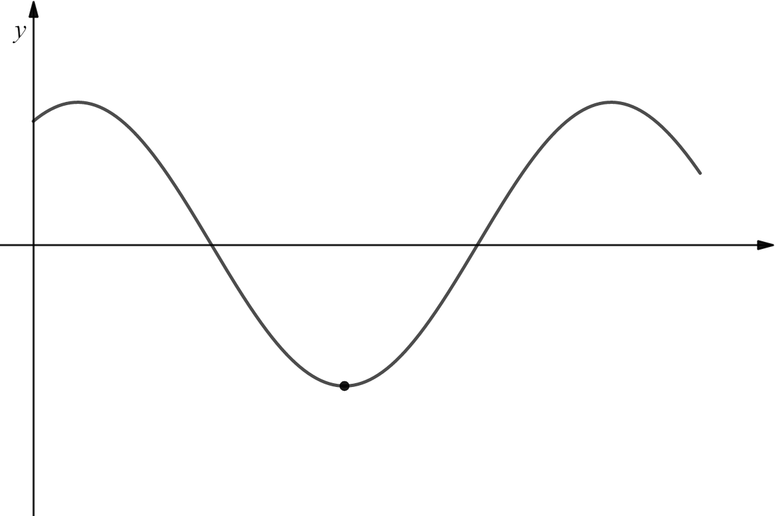

*O*

*P*

*x*

*y*

**6.**

**Figure 2**

Figure 2 shows a sketch of part of the curve with equation

*y* = 5 cos (*x* – 30)°, *x* ≥ 0.

The point *P* lies on the curve and is the minimum point with smallest positive *x-*coordinate.

(a) State the coordinates of *P*.

**(2)**

(b) Solve, for 0 ≤ *x* < 360, the equation

5 cos (*x* – 30)° = 4 sin *x*°,

giving your answers to one decimal place.

**(4)**

(c) Deduce, giving reasons for your answer, the **number of roots** of the equation

5 cos (2*x* – 30)° = 4 sin 2*x*°

for 0 ≤ *x* < 3600.

**(2)**

**(Total for Question 6 is 8 marks)**

**___________________________________________________________________________**

**7.** **In this question you must show all stages of your working.**

**Solutions relying entirely on calculator technology are not acceptable.**

(*a*)Show that

cosec *θ* − sin *θ* ≡ cos *θ* cot *θ θ* ≠ (180*n*)° *n* ∈ 𝕫

**(3)**

(*b*)Hence, or otherwise, solve for 0 < *x* < 180°

cosec *x* − sin*x* = cos*x*cot(3*x* − 50°)

**(5)**

**(Total for Question 7 is 8 marks)**

___________________________________________________________________________

**8.**



Circle *C*1 has equation *x*2 + *y*2 = 100

Circle *C*2 has equation (*x* − 15)2 + *y*2 = 40

The circles meet at points *A* and *B* as shown in Figure 3.

(*a*)Show that angle *AOB* = 0.635 radians to 3 significant figures, where O is the origin.

**(4)**

The region shown shaded in Figure 3 is bounded by *C*1 and *C*2

(*b*)Find the perimeter of the shaded region, giving your answer to one decimal place.

**(4)**

**(Total for Question 8 is 8 marks)**

___________________________________________________________________________

**9.** (i) Solve, for 0 ≤ *x* < , the equation

4 sin *x* = sec *x*.

**(4)**

(ii) Solve, for 0 ≤ *θ* < 360*°*, the equation

5 sin *θ* − 5 cos *θ* = 2,

giving your answers to one decimal place.

(*Solutions based entirely on graphical or numerical methods are not acceptable*.)

**(5)**

**(Total for Question 9 is 9 marks)**

___________________________________________________________________________

**10. In this question you must show all stages of your working.**

**Solutions relying entirely on calculator technology are not acceptable.**

(*a*)Show that

cos 3 *A* ≡ 4 cos3 *A* − 3 cos *A*

**(4)**

(*b*)Hence solve, for −90° ≤ *x* ≤ 180°, the equation

1 − cos 3*x* = sin2 *x*

**(4)**

**(Total for Question 10 is 8 marks)**

**___________________________________________________________________________**

**11.** (*a*) Express 10 cos *θ* – 3 sin *θ* in the form *R* cos (*θ* + 𝛼), where *R* > 0 and 0 < 𝛼 < 90°.

Give the exact value of *R* and give the value of 𝛼, in degrees, to 2 decimal places.

**(3)**



**Figure 3**

The height above the ground, *H* metres, of a passenger on a Ferris wheel *t* minutes after the wheel starts turning, is modelled by the equation

*H* = *a* – 10 cos (80*t*)° + 3 sin (80*t*)°

where *a* is a constant.

Figure 3 shows the graph of *H* against *t* for two complete cycles of the wheel.

Given that the initial height of the passenger above the ground is 1 metre,

(*b*) (i) find a complete equation for the model.

(ii) Hence find the maximum height of the passenger above the ground.

**(2)**

(*c*) Find the time taken, to the nearest second, for the passenger to reach the maximum height on the second cycle.

(*Solutions based entirely on graphical or numerical methods are not acceptable.*)

**(3)**

It is decided that, to increase profits, the speed of the wheel is to be increased.

(*d*) How would you adapt the equation of the model to reflect this increase in speed?

**(1)**

**(Total for Question 11 is 9 marks)**

___________________________________________________________________________