Q | Scheme | Marks | AOs | Pearson Progression Step and Progress descriptor
1 | X ~ females X ~ N(165, 9²), Y ~ males Y ~ N(178, 10²) | M1 | 3.3 | 5th  Calculate probabilities for the standard normal distribution using a calculator.
 | P(X >177) = P(Z >1.33) (or = 0.0912) | M1 | 1.1b
 | P(Y >190) = P(Z > 1.20) (or = 0.1151) | A1 | 1.1b
 | Therefore the females are relatively taller. | A1 | 2.2a
(4 marks)
Notes

Q | Scheme | Marks | AOs | Pearson Progression Step and Progress descriptor
2a | P(M < 850) = 0.3085 (using calculator) | B1 | 1.1b | 5th  Calculate probabilities for the standard normal distribution using a calculator.
 |  | (1)
2b | P(M < a) = 0.1 and P(M < b) = 0.9 | M1 | 3.1b | 5th  Calculate probabilities for the standard normal distribution using a calculator.
 | (using calculator) a = 772 g | A1 | 1.1b
 | b = 1028 g | A1 | 1.1b
 |  | (3)
(4 marks)
Notes

Q | Scheme | Marks | AOs | Pearson Progression Step and Progress descriptor
3 | X ~ B(200, 0.54) | B1 | 3.3 | 7th  Use the normal distribution to approximate a binomial distribution.
 | Y ~ N(108, 49.68) | B2 | 3.1b
 | P(X > 100) = P(X ⩾ 101) | M1 | 3.4
 | = P | M1 | 1.1b
 | = P(Z ⩾ −1.06...) = 0.8554 | A1 | 1.1b
(6 marks)
Notes

Q | Scheme | Marks | AOs | Pearson Progression Step and Progress descriptor
4a | 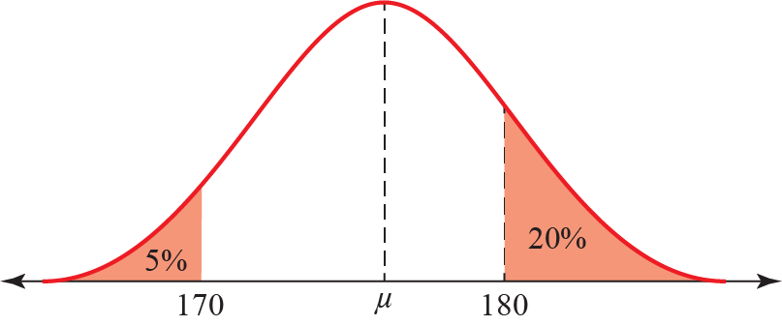  bell shaped | B1 | 1.2 | 5th  Understand the basic features of the normal distribution including parameters, shape and notation.
 | 170, 180 on axis | B1 | 1.1b
 | 5% and 20% | B1 | 1.1b
 |  | (3)
4b | P(X < 170) = 0.05  μ = 170 + 1.6449σ  P(X > 180) = 0.2  μ = 180 − 0.8416σ  Solving simultaneously gives:  μ = 176.615… (awrt 176.6) and σ = 4.021…(awrt 4.02) | M1  B1  B1  B1  M1  A1  A1 | 3.3  3.4  1.1b  3.4  1.1b  1.1b  1.1b | 7th  Find unknown means and/or standard deviations for normal distributions.
 |  | (7)
4c | P(All three are taller than 175 cm) = 0.656…³ | M1 | 1.1b | 5th  Understand informally the link to probability distributions.
 | = 0.282… (using calculator) awrt 0.282 | A1 | 1.1b
 |  | (2)
(12 marks)
Notes

Q | Scheme | Marks | AOs | Pearson Progression Step and Progress descriptor
5a | n is large | B1 | 1.2 | 5th  Understand the binomial distribution (and its notation) and its use as a model.
 | p is close to 0.5 | B1 | 1.2
 |  | (2)
5b | Mean = np | B1 | 1.2 | 5th  Understand the binomial distribution (and its notation) and its use as a model.
 | Variance = np(1 − p) | B1 | 1.2
 |  | (2)
5c | There would be no batteries left. | B1 | 2.4 | 5th  Select and critique a sampling technique in a given context.
 |  | (1)
5d | H₀: p = 0.55 H₁: p > 0.55 | B1 | 2.5 | 5th  Carry out 1-tail tests for the binomial distribution.
 |  | (1)
5e | X ~ N(165, 74.25)  P(X ⩾ 183.5)  = P  = P(Z ⩾ 2.146...)  =1 − 0.9838  = 0.0159  Reject H₀, it is in the critical region.  There is evidence to support the manufacturer's claim. | B1  M1  M1  A1  A1  M1  A1 | 3.3  3.4  1.1b  1.1b  1.1b  1.1b  2.2b | 7th  Interpret the results of a hypothesis test for the mean of a normal distribution.
 |  | (7)
(13 marks)
Notes

Q | Scheme | Marks | AOs | Pearson Progression Step and Progress descriptor
6a | Bell shaped. | B1 | 2.2a | 5th  Understand the basic features of the normal distribution including parameters, shape and notation.
 |  | (1)
6b | X ~ Daily mean pressure X ~ N(1006, 4.4²) | M1 | 3.3 | 5th  Calculate probabilities for the standard normal distribution using a calculator.
 | P(X < 1000) = 0.0863 | A1 | 1.1b
 |  | (2)
6c | A sensible reason. For example,  The tails of a Normal distribution are infinite.  Cannot rule out extreme events. | B1 | 2.4 | 5th  Understand the basic features of the normal distribution including parameters, shape and notation.
 |  | (1)

6d | Comparison and sensible comment on means. For example,  The mean daily mean pressure for Beijing is less than Jacksonville.  This suggests better weather in Jacksonville.  Comparison and sensible comment on standard deviations. For example,  The standard deviation for Beijing is greater than that for Jacksonville.  This suggests more consistent weather in Jacksonville.  Student claim could be correct. | B1  B1  B1  B1 | 2.2b  2.2b  2.2b  2.2b | 8th  Solve real-life problems in context using probability distributions.
 |  | (4)
(8 marks)
Notes
6a
Do not accept symmetrical with no discription of the shape.
6d
B2 for Suggests better weather in Jacksonville but less consistent.

Q | Scheme | Marks | AOs | Pearson Progression Step and Progress descriptor
7a | X ~ women’s body temperature X ~ N(36.73, 0.1482) | M1 | 3.3 | 5th  Calculate probabilities for the standard normal distribution using a calculator.
 | P(X > 38.1) = 0.000186 | B1 | 1.1b
 |  | (2)
7b | Sensible reason. For example,  Call the doctor as very unlikely the temperature would be so high. | B1 | 2.2a | 8th  Solve real-life problems in context using probability distributions.
 |  | (1)
(3 marks)
Notes

