1 Given that 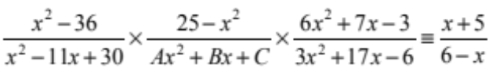
find the values of the constants A, B and C, where A, B and C are integers. (5 marks)
2 Express 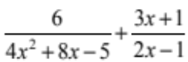 as a single fraction in its simplest form. (4 marks)
3 Show that 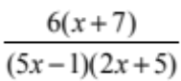 can be written in the form 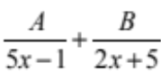
Find the values of the constants A and B. (5 marks)
4 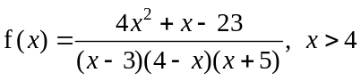
Given that f (x) can be expressed in the form 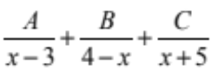
find the values of A, B and C. (6 marks)
5 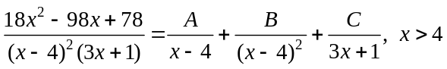
Find the values of the constants A, B and C. (6 marks)
6 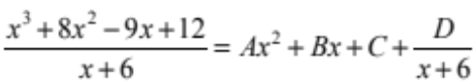
Find the values of the constants A, B, C and D. (5 marks)
7 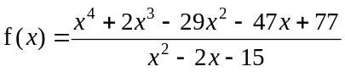
Show that f (x) can be written as 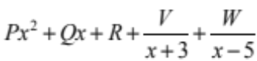 and find the values of P, Q, R, V and W. (7 marks)

8 Find the values of the constants A, B, C, D and E in the following identity: (5 marks)
9 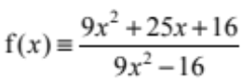
Show that f (x) can be written in the form 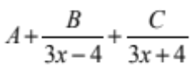, where A, B and C are constants to be found. (7 marks)

