**PAPER N**

**MARK SCHEME**

**PURE MATHEMATICS**

**A level Practice Papers**

|  |  |
| --- | --- |
| Attempts to write a differential equation.  **1**  For example,oris seen. | **M1** |
| States | **A1** |
| **TOTAL: 2 marks** |  |

|  |  |
| --- | --- |
| Finds  **2** | **M1** |
| States | **M1** |
| Solves to find. Accept awrt 101.3° | **A1** |
| **TOTAL: 3 marks** |  |

|  |  |
| --- | --- |
| Begins the proof by assuming the opposite is true.  **3**  ‘Assumption: there do exist integers *a* and *b* such that ’ | **B1** |
| Understands that  ‘As both 25 and 15 are multiples of 5, divide both sides by 5 to leave ’ | **M1** |
| Understands that if *a* and *b* are integers, then 5*a* is an integer, 3*b* is an integer  and 5*a +* 3*b* is also an integer. | **M1** |
| Recognises that this contradicts the statement that , asis not an integer.  Therefore there do not exist integers *a* and *b* such that ’ | **B1** |
| **TOTAL: 4 marks** |  |

|  |  |
| --- | --- |
| Selects as the appropriate trigonometric identity.  **4** | **M1** |
| Manipulates the identity to the question: | **M1** |
| States that | **M1** |
| Makes an attempt to integrate the expression, *x* and sin *x* are seen. | **M1** |
| Correctly states | **A1** |
| **TOTAL: 5 marks** |  |

**NOTES:**

Student does not need to state ‘+C’ to be awarded the third method mark.

Must be stated in the final answer.

**5**

|  |  |
| --- | --- |
| Begins the proof by assuming the opposite is true.  ‘Assumption: there exists a product of two odd numbers that is even.’ | **B1** |
| Defines two odd numbers. Can choose any two different variables.  ‘Let 2*m +* 1 and 2*n +* 1 be our two odd numbers.’ | **B1** |
| Successfully multiplies the two odd numbers together: | **M1** |
| Factors the expression and concludes that this number must be odd.    is even, so  must be odd. | **M1** |
| Makes a valid conclusion.  This contradicts the assumption that the product of two odd numbers is even, therefore the product of two odd numbers is odd. | **B1** |
| **TOTAL: 5 marks** |  |

**NOTES:** **Alternative method**

Assume the opposite is true: there exists a product of two odd numbers that is even. (**B1)**

If the product is even then 2 is a factor. (**B1)**

So 2 is a factor of at least one of the two numbers. (**M1)**

So at least one of the two numbers is even. (**M1)**

This contradicts the statement that both numbers are odd. (**B1)**

|  |  |
| --- | --- |
| States that:  **6** | **M1** |
| Further states that: | **M1** |
| Equates the various terms.  Equating the coefficients of *x*2:  Equating the coefficients of *x*:  Equating constant terms: | **M1\*** |
| Makes an attempt to manipulate the expressions in order to find *A*, *B* and *C*. Obtaining two different equations in the same two variables would constitute an attempt. | **M1\*** |
| Finds the correct value of any one variable:  either *A* = 2, *B* = 5 or *C* = −1 | **A1\*** |
| Finds the correct value of all three variables:  *A* = 2, *B* = 5, *C* = −1 | **A1** |
| **TOTAL: 6 marks** |  |

NOTES: Alternative method

Uses the substitution method, having first obtained this equation: (**M3 as above**)

Substitutes *x* = 4 to obtain 9*B* = 45 (**M1**)

Substitutes *x* = 3 to obtain 8*A* = 16 (**M1**)

Substitutes *x* = −5 to obtain −72*C* = 72 (**A1**)

|  |  |
| --- | --- |
| Demonstrates an attempt to find the vectors,and  **7** | **M1** |
| Finds,and | **A1** |
| Demonstrates an attempt to find,and | **M1** |
| Finds Finds  Finds | **A1** |
| States or implies in a right-angled triangle | **M1** |
| States that | **B1** |
| **TOTAL: 6 marks** |  |

|  |  |
| --- | --- |
| Rearrangesto obtain  8a | **M1** |
| Substitutesinto  For example,is seen. | **M1** |
| Finds | **A1** |
|  | **(3 marks)** |
| Deduces that the width of the arch can be found by substituting  into  8b | **M1** |
| Finds *x* = 0 and *x* = 160 and deduces the width of the arch is 160 m. | **A1** |
|  | **(2 marks)** |
| Deduces that the greatest height occurs when  8b | **M1** |
| Deduces that the height is 100 m. | **A1** |
|  | **(2 marks)** |
| **TOTAL: 7 marks** |  |

9a

|  |  |
| --- | --- |
| Finds and | **M1** |
| Change of sign and continuous function in the interval root | **A1** |
|  | **(2 marks)** |
| Makes an attempt to differentiate f(*x*)  9b | **M1** |
| Correctly finds | **A1** |
| Finds and | **M1** |
| Attempts to find: | **M1** |
| Finds | **A1** |
|  | **(5 marks)** |
| **TOTAL: 7 marks** |  |

**NOTES: 9a**

Minimum required is that answer states there is a sign change in the interval and that this implies a root in the given interval

|  |  |
| --- | --- |
| Use Pythagoras’ theorem to show that the length oforor states  10 | **M1** |
| Makes an attempt to findor. For example,is seen. | **M1** |
| Correctly states thator | **A1** |
| Makes an attempt to find the area of the sector with a radius of 4 and a subtended angle of  For example,is shown. | **M1** |
| Correctly states that the area of the sector is | **A1** |
| Recognises the need to subtract the sector area from the area of the rhombus in an attempt to find the shaded area. For example,is seen. | **M1** |
| Recognises that to find the total shaded area this number will need to be multiplied by 2  For example, | **M1** |
| Using clear algebra, correctly manipulates the expression and gives a clear final answer of | **A1** |
| **TOTAL: 8 marks** |  |

11a

|  |  |
| --- | --- |
| Differentiates obtaining and differentiates obtaining | **M1** |
| Makes an attempt to substitute the above values into the product rule formula: | **M1** |
| Finds | **M1** |
| Fully simplfies using correct algebra to obtain | **A1** |
|  | **(4 marks)** |
| Makes an attempt to substitute *t* = 2 into  11b | **M1 ft** |
| Correctly findsand concludes that asthe toy soldier was decreasing  in height after 2 seconds. | **B1 ft\*** |
|  | **(2 marks)** |
| = 0 or at a turning point.  11c | **M1 ft** |
| Solvesto find Can also state | **A1 ft** |
|  | **(2 marks)** |
| **TOTAL: 8 marks** |  |

**NOTES:**

**11b:** Award ft marks for a correct answer using an incorrect answer from part **a**.

**B1:** Can also stateas the numerator ofis negative and the denominator is positive.

**11c:** Award ft marks for a correct answer using an incorrect answer from part **a**.

|  |  |
| --- | --- |
| Clear attempt to reflect the negative part of the original graph in the *x*-axis.  12a | **M1** |
| Labels all three points correctly. | **A1** |
| Fully correct graph. (see below) | **A1** |
|  | **(3 marks)** |
| Clear attempt to reflect the positive *x* part of the original graph in the *y*-axis.  12b | **M1** |
| Labels all three points correctly. | **A1** |
| Fully correct graph. (see below) | **A1** |
|  | **(3 marks)** |
| Clear attempt to move the graph to the left 3 spaces.  12c |  |
| Clear attempt to stretch the graph vertically by a factor of 2. |  |
| Fully correct graph. (see below) |  |
|  | **(3 marks)** |
| **TOTAL: 9 marks** |  |

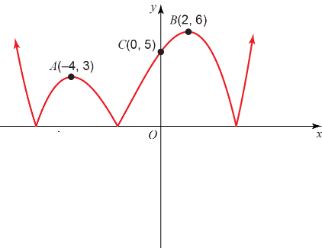 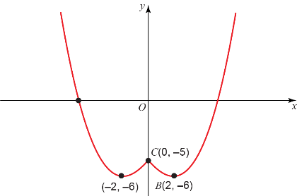 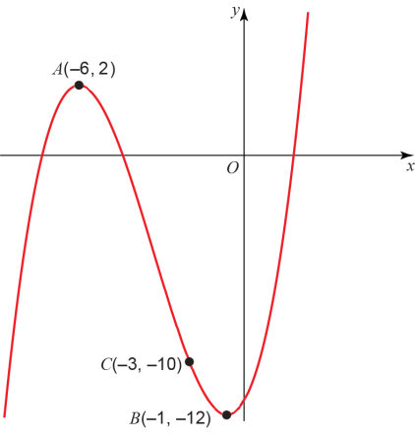

12c

12b

12a

13a

|  |  |
| --- | --- |
| Recognises that it is a geometric series with a first term  and common ratio | **M1** |
| Attempts to use the sum of a geometric series.  For example,  or  is seen. | **M1\*** |
| Finds | **A1** |
|  | **(3 marks)** |
| States  or  13b | **M1** |
| Begins to simplify.  or | **M1** |
| Applies law of logarithms correctly  or | **M1** |
| States | **A1** |
|  | **(4 marks)** |
| Uses the sum of an arithmetic series to state  13c | **M1** |
| Solves for *d*. *d* = £11.21 | **A1** |
|  | **(2 marks)** |
| **TOTAL: 9 marks** |  |

**NOTES: 13a:**

**M1** Award mark if attempt to calculate the amount of money after 1, 2, 3,….,8 and 9 months is seen.

|  |  |
| --- | --- |
| Writes  as  14a | **M1** |
| Expands | **M1** |
| Simplifies:  Award mark even if *x2* term is not seen. | **M1** |
| Uses  to write *a* = 64. | **A1** |
| Uses to write *b* = –6. | **A1** |
|  | **(5 marks)** |
| States expansion is valid for  14b | **B1 ft** |
| Solves to state | **A1 ft** |
| 14c | **(2 marks)** |
| Substitutes *a* = 64 and *b* = –6 into | **M1 ft** |
| Finds | **A1 ft** |
|  | **(2 marks)** |
| **TOTAL: 9 marks** |  |

**NOTES:**

**14a:** Note *x*2 term is not necessary to answer part **a**, so is not required. Will be needed to answer part **c**.

**14b:** Award marks for a correct conclusion using incorrect values of *a* and *b* from part **a**.

**14c:** Award marks for a correct answer using incorrect values of *a* and *b* from part **a**.

|  |  |
| --- | --- |
| States  15a | **M1** |
| Deduces that | **M1** |
| Findsand/or | **M1** |
| States | **M1** |
| Makes an attempt to find | **M1** |
| Shows a clear logical progression to state | **A1** |
|  | **(6 marks)** |
| Separates the variables  15b | **M1** |
| Finds | **A1** |
| Uses the fact that *t* = 0 when *h* = 50 m to find *C*: | **M1** |
| Substitutes *h =* 60 into the equation: | **M1** |
| Uses law of logarithms to write: | **M1** |
| States correct final answer: minutes. | **A1** |
|  | **(6 marks)** |
| **TOTAL: 12 marks** |  |

**(TOTAL: 100 MARKS)**